WEEK 3: EDUCATION
***
Part 1: Social Interaction (3’)
Let’s talk about distance learning:
1. How has distance learning impacted your educational experience?
2. What challenges have you faced while participating in distance learning?
3. How do you stay motivated and focused while learning remotely?

Let’s talk about your English study:
1. Have you learned English on any online learning apps?
2. Are there challenges you've had during your English study journey?
3. Have you had the opportunity to practice conversational English with native speakers?

Part 2: Solution Discussion (4’)
Situation: You are planning to enhance your life skills. There are 3 options: attending a traditional classroom course; exploring an online course; or participating in hands-on workshops. Which one do you think is the best choice? What are the reasons for choice?

Part 3: Topic Development (5’)

Topic: Roles of distance learning in university education

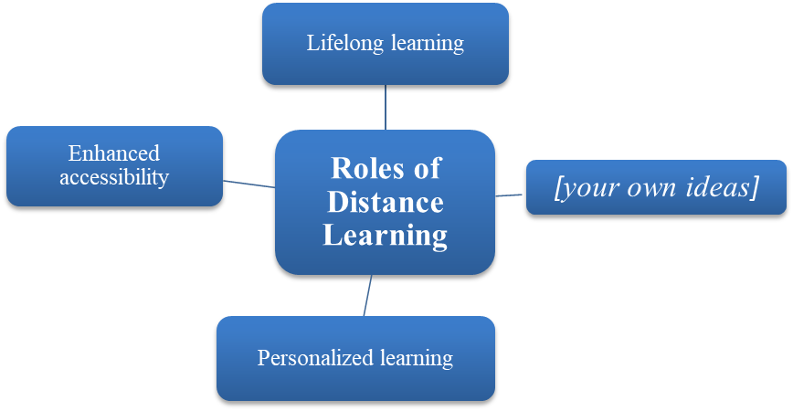

Follow-up questions:
1. In what ways are the online materials beneficial for your studies?
2. How does the evaluation process differ in distance learning compared to in-person classes?

